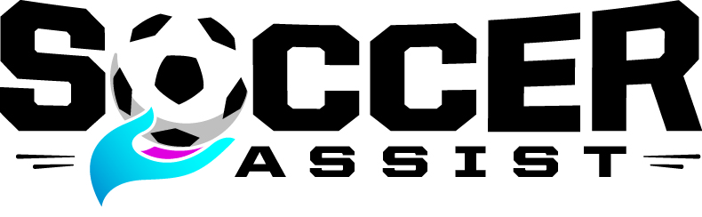

2016 Sponsorship Levels

Platinum - $10,000

- Name and/or logo on all invites + advertising
- Name and/or logo on all 2016 t-shirts – youth and adult (estimated 500)
- Logo on step and repeat banner for PGI party (estimated attendance 600)
- 30 customized soccer balls, with company logo (others given to kids)
- Banner in primary location at Landon Donovan/HELM camp (June 2-4)
- Private photo opportunity with HELM Founders, including Landon Donovan
- Banner on Houston Dynamo stadium tour for 2015 scholarship recipients
- Logo featured at all 2016 Soccer Assist trainings/camps
- Annual updates from 2016 scholarship recipients
- Logo on website, all banners and projections during PGI party
- 20 comped guests to PGI party (value $2,000)

Diamond - $5,000

- Name and logo on all invites + advertising
- Logo on Step and Repeat banner for PGI party (estimated attendance 600)
- Banner on Houston Dynamo stadium tour (May, 2016)
- Private photo opportunity with HELM Founders, including Landon Donovan
- Logo featured at all 2016 Soccer Assist trainings/camps
- 15 customized soccer balls, with company logo (others given to kids)
- Logo on website, program banners, and projections during PGI party
- 10 comped guests to PGI party (value $1,000)

Gold - $2,500

- Logo on website and program banners
- Private photo opportunity with HELM Founders, including Landon Donovan
- 10 Soccer Assist soccer balls
- 8 comped guests to PGI party (value $800)

Silver - $1,000

- Logo on website and program banners
- Private photo opportunity with HELM Founders, including Landon Donovan
- 4 comped guests to PGI party (value $400)

soccerasstatx@gmail.com 512-627-4042 2212 East Windsor Road, Austin TX 78703

